**Test Case 6**

**System:** Bench

**Description:** Test for sending image functionality.

**Severity:** 4

**Instructions**

**Test 1**

1. Start the Bench application.
2. Click the button “Login” on the navigation bar.
3. Enter the email “user1@gmail.com” into the text field labeled “Email address”.
4. Enter the password “12345678” into the field labeled “Password”.
5. Click the button “Login” below the field.
6. After the screen has loaded, click on the button “Chat” on the navigation bar.
7. Click on any of the existing chat panels listed on the left sidebar.
8. Click on the image button on the right of the input field.

**Expected Result:** A file finder should pop up on the screen to allow the current user to select an image file to send.

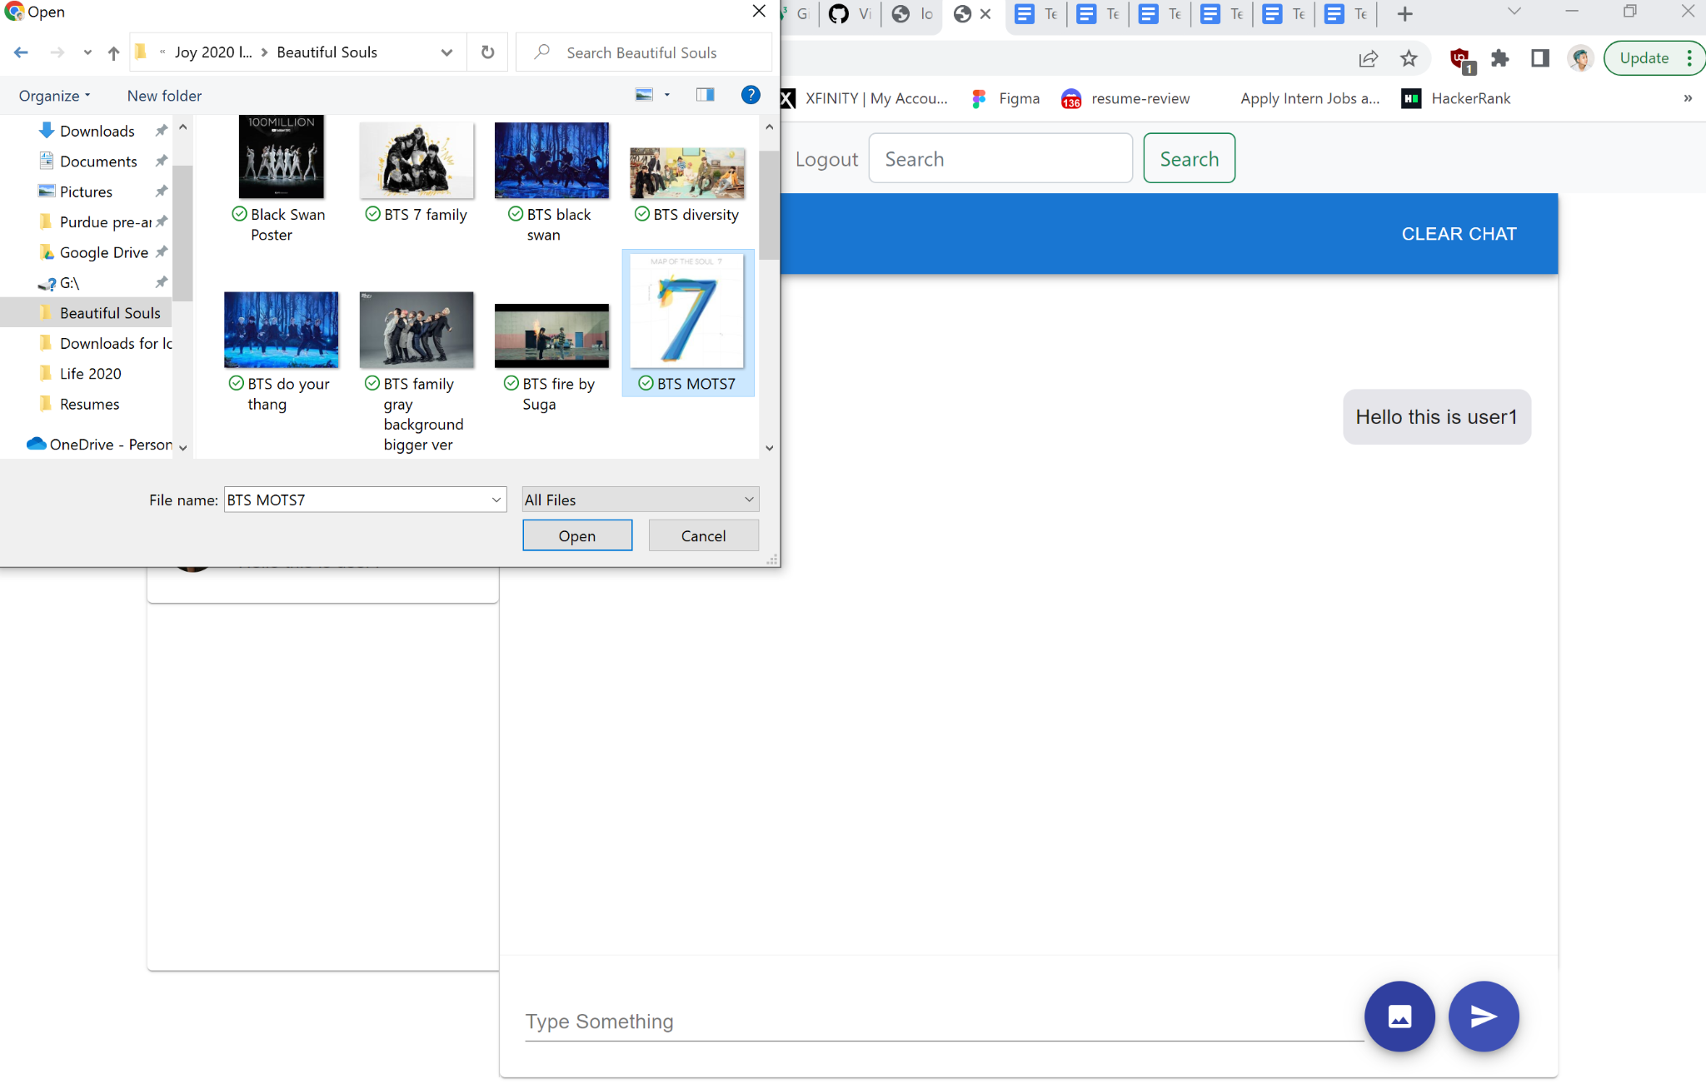

**Test 2**

1. Start the Bench application.
2. Click the button “Login” on the navigation bar.
3. Enter the email “user1@gmail.com” into the text field labeled “Email address”.
4. Enter the password “12345678” into the field labeled “Password”.
5. Click the button “Login” below the field.
6. After the screen has loaded, click on the button “Chat” on the navigation bar.
7. Click on any of the existing chat panels listed on the left sidebar.
8. Click on the image button on the right of the input field.
9. A file finder should pop up on the screen to allow the current user to select an image file to send.
10. Select an image file from the file finder, and click the send button.

**Expected Result:** The image size in the chat box should be scaled according to true proportion in the chat history.

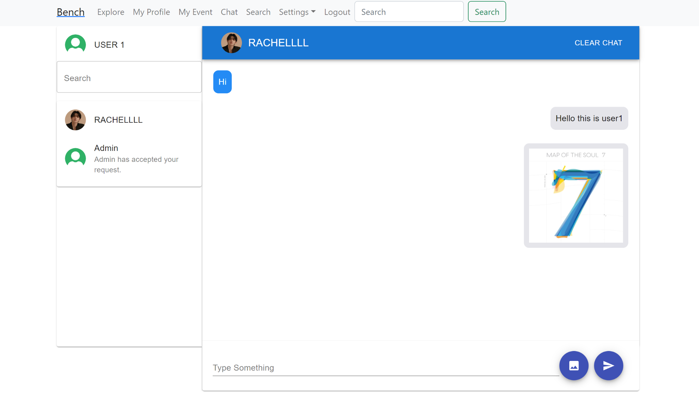

**Test 3**

1. On device “A”, Start the Bench application.
2. Click the button “Login” on the navigation bar.
3. Enter the email “user1@gmail.com” into the text field labeled “Email address” to login as user user1.
4. Enter the password “12345678” into the field labeled “Password”.
5. Click the button “Login” below the field.
6. After the screen has loaded, click on the button “Chat” on the navigation bar.
7. Click on the chat panel labeled with the username “RACHELLLL”.
8. Click on the image button on the right of the input field.
9. A file finder should pop up on the screen to allow the current user to select an image file to send.
10. Select an image file from the file finder, and click the send button.
11. Check if the image can be seen in the chat history on user1’s site.
12. On a different device which we call “B”, start the Bench application.
13. Click the button “Login” on the navigation bar.
14. Enter the email “rachel.la2310@gmail.com” into the text field labeled “Email address” to login as user Rachellll.
15. Enter the password “12345678” into the field labeled “Password”.
16. Click the button “Login” below the field.
17. After the screen has loaded, click on the button “Chat” on the navigation bar.
18. Click on the chat panel labeled with the username “USER1”.
19. Check if the image can be seen on Rachellll’s site.

**Expected Result:** The image should be able to be seen in the chat history on both users’ site.

